27.75: Summing the torques on the wire from gravity and the magnetic field will enable us to find the magnetic field value.

There are three sides to consider for the gravitational torque, leading to:

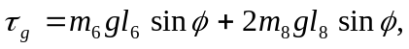

where is the moment arm from the pivot to the far 6 cm leg and is the moment arm from the pivot to the centers of mass of the 8 cm legs.

